Chapter 1 Test Date: Friday 10/4 Parent Initials:___________________

Name_______________________________ #_____ Date_________________

Social Studies Chapter 1 Review

Directions: Please write the definition for each term below:

1. social science - _______________________________________________

_______________________________________________________________

1. geographer - _______________________________________________

_______________________________________________________________

1. historian - __________________________________________________

_______________________________________________________________

1. economist - _________________________________________________

_______________________________________________________________

1. political scientist - _____________________________________________

_______________________________________________________________

Directions: Match the social scientist with the question they might ask about the post card.

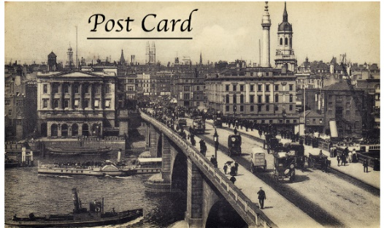

1. Where is this post card from?_______________

_________________________________________

1. How much did it cost to construct the bridge in

The picture?_______________________________

1. Were all of the laws followed when constructing

the bridge?_________________________________

1. How old is this post card?_____________________

___________________________________________

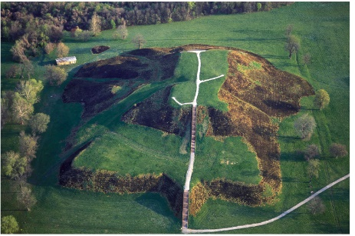This is a picture of Monks Mound in Illinois. It is part of a 1,300 year old American Indian city called Cahokia. Look at the mound, choose one of the social scientists we studied and write 2 questions that social scientist might ask about the mound.

1. The social scientist I chose is_________________________
2. 1 question this social scientist might ask about the mound is:

________________________________________________

________________________________________________

1. Another question this social scientist might ask about the mound is:

__________________________________________________________

__________________________________________________________

Directions: Write true or false in front of the statement:

1. _______ Geographers would be interested in studying the laws of a group of people.
2. _______ Political scientists would be interested in studying a family picture found in an old house.
3. ______ Economists would be interested in studying the price tag found on an old piece of clothing.
4. ______ Historians would be interested in studying a letter from the 1800s.